**300986134 Parth Chandgadhiya**

**CODE 01**

using System;

using static System.Console;

namespace ConsoleApp6

{

class Program

{

static void Main(string[] args)

{

int i = 0;

int a = 1;

while (i <= 15)

{

a = 2 * i;

WriteLine("{0}",a);

i++;

}

}

}

}

Output:

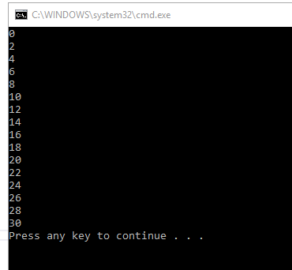

**CODE 02**

using System;

using static System.Console;

namespace ConsoleApp6

{

class Program

{

static void Main(string[] args)

{

int i = 0;

int a = 1;

while (i <= 10)

{

a = 2 * i;

WriteLine("2 x {0} = {1}",i,a);

i++;

}

}

}

}

Output:

